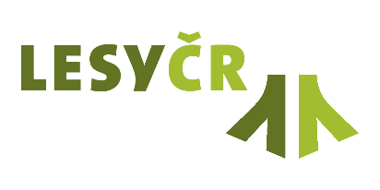 | Letter of Intent (without financial support)

1. BASIC IDENTIFICATION AND PROJECT CHARACTERISTICS
Main applicant:
(Name of organisation, Company ID No.)

Project:
(Title of the research project.)

Programme:
(Specify the source of project funding – agency, support programme.)

Project duration:
(In accordance with the terms and conditions of the relevant support programme.)

Summary:
(Project abstract: Introduction and description of the project and its objectives.)

2. APPLICATION OF PROJECT RESULTS IN COMPANY PRACTICE, COOPERATION WITH LČR AND EXPRESSION OF INTEREST
Compliance of the project with the Applied Research Concept of the LČR Grant Service, state enterprise (Koncepce aplikovaného výzkumu Grantové služby LČR), for the period 2023–2029 (as amended): (Specify which preferred thematic areas of the project aligns with, including a description of the scope and nature of this alignment. If the project spans multiple thematic areas, specify all relevant areas and describe their relations. The current version of the Applied research Concept is available on the LČR website in the Grant Service section - https://lesycr.cz/rady-a-osveta/grantova-sluzba/.)

Cooperation with LČR:
(Describe any requirements for cooperation with LČR that are necessary for successful implementation of the project, e.g., provision of data, access to field sites, expert consultations, etc.)

Benefits of the project and application of its results in LČR practice:
(specify all benefits for LČR supported sectors – forestry, water management and game management. Describe how the transfer of project results into LČR forestry operations will be carried out, e.g., through methodological recommendations, introduction of new procedures, staff training, pilot testing in the field, or implementation into internal LČR processes, etc.).)

Statement:
(Edit the text according to the specific focus and expected benefits of the project for LČR)
Example 1) We confirm that we have been informed about the interest to carry out research on the property of LČR state enterprise within the project “XY”. By signing we confirm that if the applicant is awarded the mentioned project, the research will be able to be carried out in selected sites on the property of the Forest of the Czech Republic. However, communication and coordination with the relevant forest administrations is necessary.

Example 2) The issues and objectives of the proposed project “XY” are relevant to our organization. If the project is approved, we would be interested in using the planned results in our forest practice.

In Hradec Králové, date

JUDr. Pavel Krpata
Director of Administration
Lesy České republiky, state enterprise

